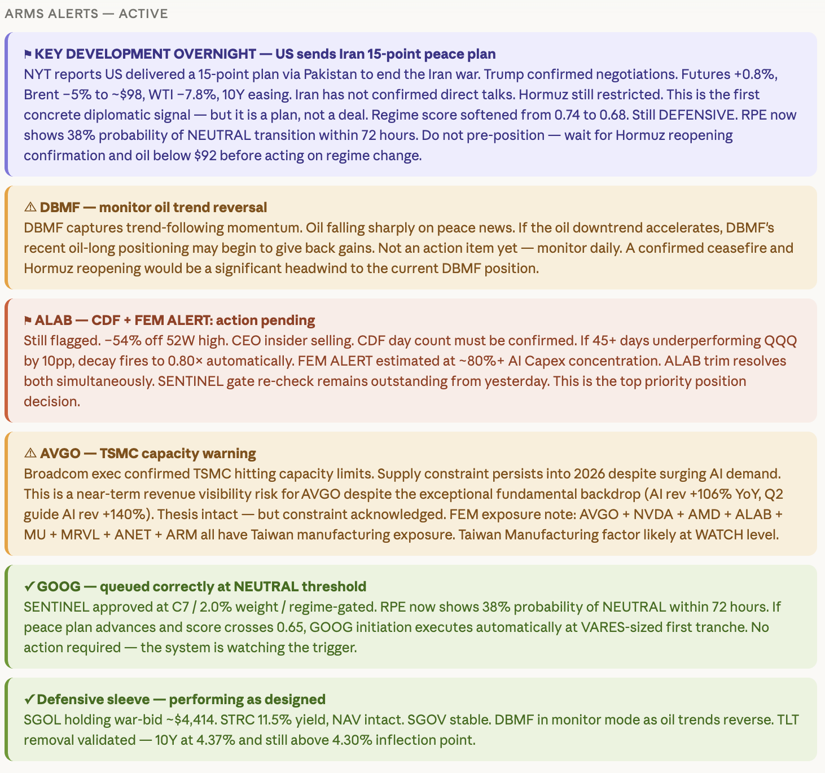
ARMS ALERTS ACTIVE
KEY DEVELOPMENT OVERNIGHT
—
US sends Iran 15-point peace plan
NYT reports US delivered a 15-point plan via Pakistan to end the Iran war. Trump confirmed negotiations. Futures +0.8%, Brent -5% to ~$98, WTI -7.8%, 10Y easing. Iran has not confirmed direct talks. Hormuz still restricted. This is the first concrete diplomatic signal — but it is a plan, not a deal. Regime score softened from 0.74 to 0.68. Still DEFENSIVE. RPE now shows 38% probability of NEUTRAL transition within 72 hours. Do not pre-position-wait for Hormuz reopening confirmation and oil below $92 before acting on regime change.
A DBMF - monitor oil trend reversal
DBMF captures trend-following momentum. Oil falling sharply on peace news. If the oil downtrend accelerates, DBMF's recent oil-long positioning may begin to give back gains. Not an action item yet - monitor daily. A confirmed ceasefire and Hormuz reopening would be a significant headwind to the current DBMF position.
ALAB - CDF + FEM ALERT: action pending
Still flagged. -54% off 52W high. CEO insider selling. CDF day count must be confirmed. If 45+ days underperforming QQQ by 10pp, decay fires to 0.80x automatically. FEM ALERT estimated at ~80%+ Al Capex concentration. ALAB trim resolves both simultaneously. SENTINEL gate re-check remains outstanding from yesterday. This is the top priority position decision.
A AVGO - TSMC capacity warning
Broadcom exec confirmed TSMC hitting capacity limits. Supply constraint persists into 2026 despite surging Al demand. This is a near-term revenue visibility risk for AVGO despite the exceptional fundamental backdrop (Al rev +106% YoY, Q2 guide Al rev +140%). Thesis intact — but constraint acknowledged. FEM exposure note: AVGO + NVDA + AMD + ALAB + MU + MRVL + ANET + ARM all have Taiwan manufacturing exposure. Taiwan Manufacturing factor likely at WATCH level.
✓ GOOG― queued correctly at NEUTRAL threshold
SENTINEL approved at C7 / 2.0% weight/regime-gated. RPE now shows 38% probability of NEUTRAL within 72 hours. If peace plan advances and score crosses 0.65, GOOG initiation executes automatically at VARES-sized first tranche. No action required - the system is watching the trigger.
✓ Defensive sleeve - performing as designed
SGOL holding war-bid ~$4,414. STRC 11.5% yield, NAV intact. SGOV stable. DBMF in monitor mode as oil trends reverse. TLT removal validated - 10Y at 4.37% and still above 4.30% inflection point.

